**So the program was ran for 1hrs and following are the changes in database:-**

1. 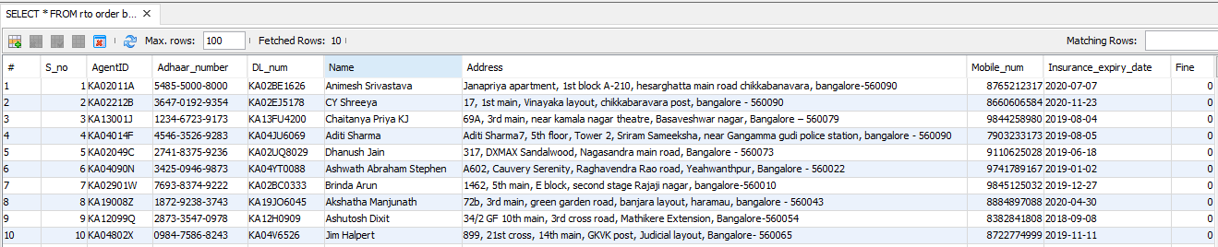Initial rto database before running the program.
2. 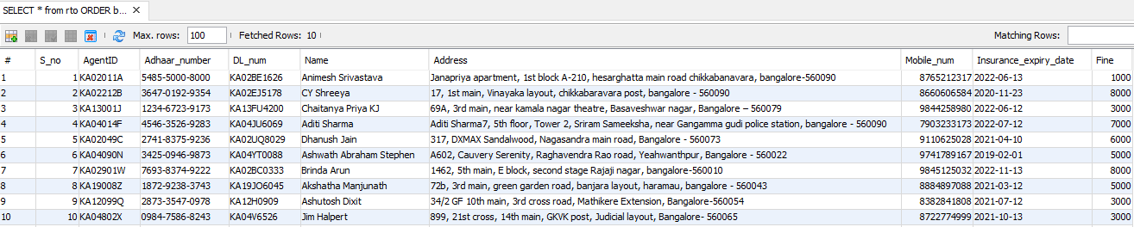 After running the program for 1hrs, the fine column in rto table got updated based on the violation.
3. 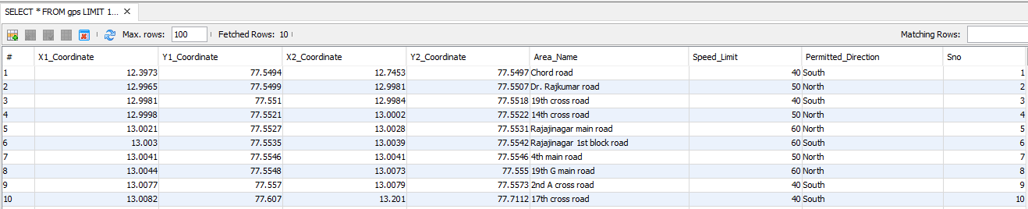Gps database which is used to get speed and permitted direction of some particular area.
4. 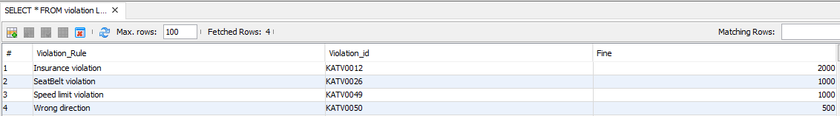Violation database which has violation id and fine to be charged for a particular violation.
5. Some user tables named as agent id which were created if not present in the database whenever violation is committed and then updated accordingly based on the type of violation committed on some date and time.

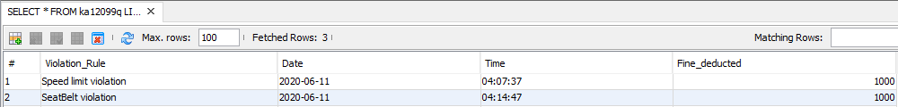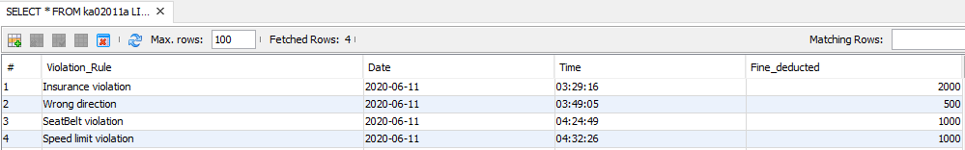

1. List of databases before executing the program.

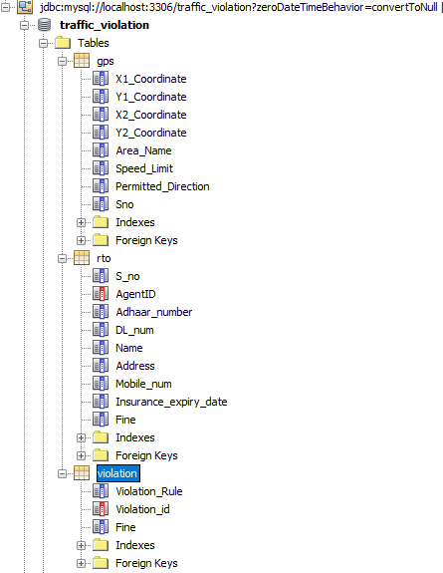

1. List of databases after executing the program for 1hrs.

